

* 4th Deliverable (ERD Diagram)
* Group Members:
  + Abdullah Ahmad Arslan (FA22-BCS-042), CGPA: 3.75, Mail: [FA22-BCS-042@cuilahore.edu.pk,](mailto:FA22-BCS-042@cuilahore.edu.pk) Phone: 03334578883
  + Muhammad Awais (FA22-BCS-185), CGPA: 3.41, Mail: [FA22-BCS-185@cuilahore.edu.pk,](mailto:FA22-BCS-185@cuilahore.edu.pk) Phone: 03320144667
* **Subject:** Database Systems
* **Professor Name:** Dr. Abid Sohail

**DAILY REPORTS(using complex views from normalized scehma):**

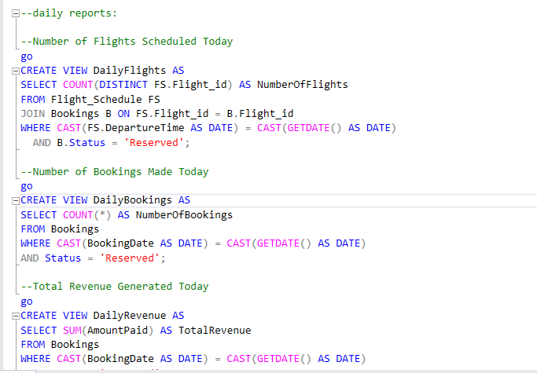

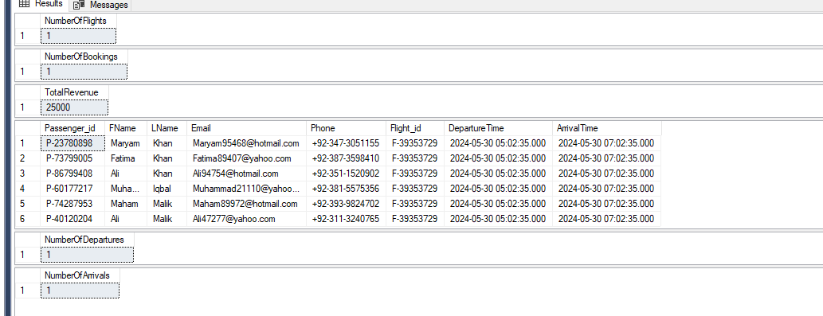

**Analytical reports(using materialized views)**

CREATE VIEW MonthlyRevenue AS

WITH UniqueBookings AS (

SELECT

DISTINCT Booking_id,

Amount_Paid,

Booking_Date

FROM

dbo.DenormalizedIndexedView

WHERE

Booking_Status = 'reserved'

)

SELECT

YEAR(Booking_Date) AS Year,

MONTH(Booking_Date) AS Month,

SUM(Amount_Paid) AS TotalRevenue

FROM

UniqueBookings

GROUP BY

YEAR(Booking_Date),

MONTH(Booking_Date);

go

--Passenger Demographics Report:

CREATE VIEW PassengerDemographics AS

SELECT

Passenger_Gender,

COUNT(DISTINCT Passenger_id) AS NumberOfPassengers,

AVG(DATEDIFF(YEAR, Passenger_DateOfBirth, GETDATE())) AS AverageAge

FROM

dbo.DenormalizedIndexedView

GROUP BY

Passenger_Gender;

go

--Flight Capacity Utilization Report(reserved ones only):

CREATE VIEW FlightCapacityUtilization AS

SELECT

Flight_id,

Aircraft_id,

Aircraft_Capacity,

COUNT(DISTINCT Booking_id) AS BookedSeats,

(COUNT(DISTINCT Booking_id) * 1.0 / Aircraft_Capacity) * 100 AS UtilizationPercentage

FROM

dbo.DenormalizedIndexedView

WHERE

Booking_Status = 'reserved'

GROUP BY

Flight_id,

Aircraft_id,

Aircraft_Capacity;

go

--Class Distribution Report:

CREATE VIEW ClassDistribution AS

SELECT

Ticket_Class,

COUNT(DISTINCT Booking_id) AS NumberOfTickets

FROM

dbo.DenormalizedIndexedView

WHERE

Booking_Status = 'reserved'

GROUP BY

Ticket_Class;

go

--Age Group Distribution Report:

CREATE VIEW AgeGroupDistribution AS

SELECT

CASE

WHEN DATEDIFF(YEAR, Passenger_DateOfBirth, GETDATE()) < 18 THEN 'Under 18'

WHEN DATEDIFF(YEAR, Passenger_DateOfBirth, GETDATE()) BETWEEN 18 AND 25 THEN '18-25'

WHEN DATEDIFF(YEAR, Passenger_DateOfBirth, GETDATE()) BETWEEN 26 AND 35 THEN '26-35'

WHEN DATEDIFF(YEAR, Passenger_DateOfBirth, GETDATE()) BETWEEN 36 AND 50 THEN '36-50'

ELSE 'Above 50'

END AS AgeGroup,

COUNT(DISTINCT Passenger_id) AS NumberOfPassengers

FROM

dbo.DenormalizedIndexedView

WHERE

Booking_Status = 'reserved'

GROUP BY

CASE

WHEN DATEDIFF(YEAR, Passenger_DateOfBirth, GETDATE()) < 18 THEN 'Under 18'

WHEN DATEDIFF(YEAR, Passenger_DateOfBirth, GETDATE()) BETWEEN 18 AND 25 THEN '18-25'

WHEN DATEDIFF(YEAR, Passenger_DateOfBirth, GETDATE()) BETWEEN 26 AND 35 THEN '26-35'

WHEN DATEDIFF(YEAR, Passenger_DateOfBirth, GETDATE()) BETWEEN 36 AND 50 THEN '36-50'

ELSE 'Above 50'

END;

go

--Popular Payment Methods Report:

CREATE VIEW PopularPaymentMethods AS

SELECT

Payment_Method,

COUNT(DISTINCT Booking_id) AS NumberOfBookings

FROM

dbo.DenormalizedIndexedView

WHERE

Booking_Status = 'reserved'

GROUP BY

Payment_Method;

go

--Flights by Booking Status:

CREATE VIEW FlightsByBookingStatus AS

SELECT

Booking_Status,

COUNT(DISTINCT Booking_id) AS NumberOfFlights

FROM

dbo.DenormalizedIndexedView

GROUP BY

Booking_Status;

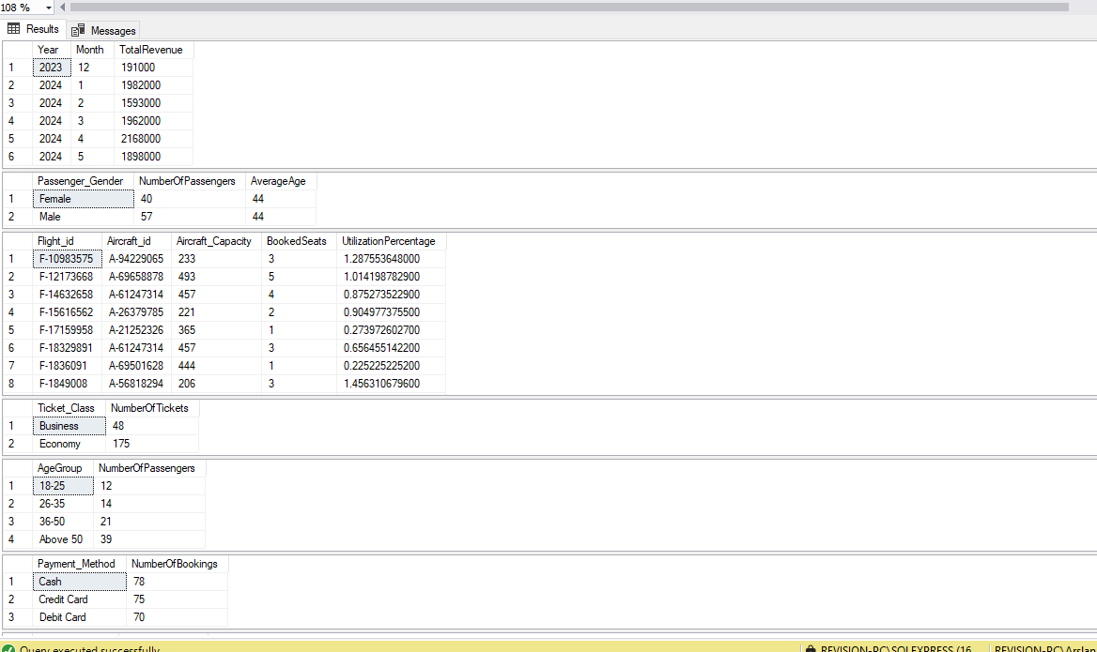

**Reports(using Procedures):**

CREATE PROCEDURE GetPassengerBookingSummary

AS

BEGIN

SELECT

p.Passenger_id,

p.FName,

p.LName,

COUNT(b.Bk_id) AS TotalBookings,

SUM(b.AmountPaid) AS TotalAmountPaid

FROM

Passengers p

LEFT JOIN

Bookings b ON p.Passenger_id = b.Passenger_id

WHERE

b.Status = 'reserved'

GROUP BY

p.Passenger_id,

p.FName,

p.LName

ORDER BY

TotalAmountPaid DESC;

END;

exec GetPassengerBookingSummary

--Flight Schedule and Crew Assignment

CREATE PROCEDURE GetFlightScheduleAndCrew

AS

BEGIN

SELECT

fs.Flight_id,

fs.DepartureTime,

fs.ArrivalTime,

a.Aircraft_Name,

ad.FName AS AdminFirstName,

ad.LName AS AdminLastName,

cs.FName AS CrewFirstName,

cs.LName AS CrewLastName,

cs.Designation

FROM

Flight_Schedule fs

JOIN

Aircrafts a ON fs.Ac_id = a.Ac_id

JOIN

Admins ad ON fs.Admin_id = ad.Admin_id

JOIN

StaffAssignments sa ON fs.Flight_id = sa.Flight_id

JOIN

Crew_Staff cs ON sa.Staff_id = cs.Staff_id

WHERE

fs.DepartureTime IS NOT NULL AND fs.ArrivalTime IS NOT NULL

ORDER BY

fs.DepartureTime;

END;

exec GetFlightScheduleAndCrew

--Revenue Breakdown by Passenger Class

CREATE PROCEDURE GetRevenueBreakdownByPassengerClass

AS

BEGIN

SELECT

t.Class,

COUNT(b.Bk_id) AS TotalBookings,

SUM(b.AmountPaid) AS TotalRevenue

FROM

Bookings b

JOIN

Tickets t ON b.Tkt_id = t.Tkt_id

WHERE

b.Status = 'reserved'

GROUP BY

t.Class

ORDER BY

TotalRevenue DESC;

END;

EXEC GetRevenueBreakdownByPassengerClass

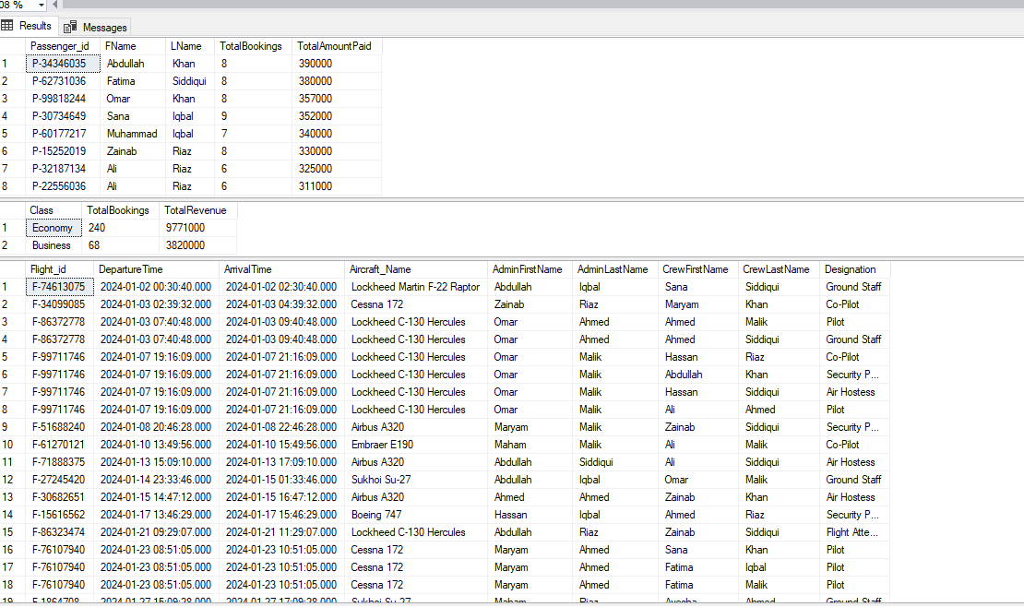

**CRUD PROCEDURES:**

--CRUD Procedures

-- CRUD procedures for Passengers table

CREATE PROCEDURE InsertPassenger

@Passenger_id VARCHAR(10),

@FName VARCHAR(100),

@LName VARCHAR(100),

@Email VARCHAR(100),

@Phone VARCHAR(20),

@Address VARCHAR(255),

@DateOfBirth DATE,

@Gender VARCHAR(10),

@Cnic VARCHAR(50),

@passport_no VARCHAR(10)

AS

BEGIN

INSERT INTO Passengers (Passenger_id, FName, LName, Email, Phone, Address, DateOfBirth, Gender, Cnic, passport_no)

VALUES (@Passenger_id, @FName, @LName, @Email, @Phone, @Address, @DateOfBirth, @Gender, @Cnic, @passport_no);

END;

GO

CREATE PROCEDURE UpdatePassenger

@Passenger_id VARCHAR(10),

@FName VARCHAR(100),

@LName VARCHAR(100),

@Email VARCHAR(100),

@Phone VARCHAR(20),

@Address VARCHAR(255),

@DateOfBirth DATE,

@Gender VARCHAR(10),

@Cnic VARCHAR(50),

@passport_no VARCHAR(10)

AS

BEGIN

UPDATE Passengers

SET FName = @FName,

LName = @LName,

Email = @Email,

Phone = @Phone,

Address = @Address,

DateOfBirth = @DateOfBirth,

Gender = @Gender,

Cnic = @Cnic,

passport_no = @passport_no

WHERE Passenger_id = @Passenger_id;

END;

GO

CREATE PROCEDURE DeletePassenger

@Passenger_id VARCHAR(10)

AS

BEGIN

DELETE FROM Passengers WHERE Passenger_id = @Passenger_id;

END;

GO

CREATE PROCEDURE SelectAllPassengers

AS

BEGIN

SELECT * FROM Passengers;

END;

GO

-- Procedure to check a specific passenger record

CREATE PROCEDURE CheckPassenger

@Passenger_id VARCHAR(10)

AS

BEGIN

SELECT * FROM Passengers WHERE Passenger_id = @Passenger_id;

END;

GO

-- CRUD procedures for Aircrafts table

CREATE PROCEDURE InsertAircraft

@Ac_id VARCHAR(10),

@Aircraft_Name VARCHAR(100),

@Model VARCHAR(100),

@Capacity INT

AS

BEGIN

INSERT INTO Aircrafts (Ac_id, Aircraft_Name, Model, Capacity)

VALUES (@Ac_id, @Aircraft_Name, @Model, @Capacity);

END;

GO

CREATE PROCEDURE UpdateAircraft

@Ac_id VARCHAR(10),

@Aircraft_Name VARCHAR(100),

@Model VARCHAR(100),

@Capacity INT

AS

BEGIN

UPDATE Aircrafts

SET Aircraft_Name = @Aircraft_Name,

Model = @Model,

Capacity = @Capacity

WHERE Ac_id = @Ac_id;

END;

GO

CREATE PROCEDURE DeleteAircraft

@Ac_id VARCHAR(10)

AS

BEGIN

DELETE FROM Aircrafts WHERE Ac_id = @Ac_id;

END;

GO

CREATE PROCEDURE SelectAllAircrafts

AS

BEGIN

SELECT * FROM Aircrafts;

END;

GO

-- Procedure to check a specific aircraft record

CREATE PROCEDURE CheckAircraft

@Ac_id VARCHAR(10)

AS

BEGIN

SELECT * FROM Aircrafts WHERE Ac_id = @Ac_id;

END;

GO

-- CRUD procedures for Tickets table

CREATE PROCEDURE InsertTicket

@Tkt_id VARCHAR(50),

@Class VARCHAR(50),

@Ticket_from VARCHAR(100),

@Ticket_to VARCHAR(100),

@Price FLOAT

AS

BEGIN

INSERT INTO Tickets (Tkt_id, Class, Ticket_from, Ticket_to, Price)

VALUES (@Tkt_id, @Class, @Ticket_from, @Ticket_to, @Price);

END;

GO

CREATE PROCEDURE UpdateTicket

@Tkt_id VARCHAR(50),

@Class VARCHAR(50),

@Ticket_from VARCHAR(100),

@Ticket_to VARCHAR(100),

@Price FLOAT

AS

BEGIN

UPDATE Tickets

SET Class = @Class,

Ticket_from = @Ticket_from,

Ticket_to = @Ticket_to,

Price = @Price

WHERE Tkt_id = @Tkt_id;

END;

GO

CREATE PROCEDURE DeleteTicket

@Tkt_id VARCHAR(50)

AS

BEGIN

DELETE FROM Tickets WHERE Tkt_id = @Tkt_id;

END;

GO

CREATE PROCEDURE SelectAllTickets

AS

BEGIN

SELECT * FROM Tickets;

END;

GO

-- Procedure to check a specific ticket record

CREATE PROCEDURE CheckTicket

@Tkt_id VARCHAR(50)

AS

BEGIN

SELECT * FROM Tickets WHERE Tkt_id = @Tkt_id;

END;

GO

-- CRUD procedures for Admins table

CREATE PROCEDURE InsertAdmin

@Admin_id VARCHAR(250),

@FName VARCHAR(100),

@LName VARCHAR(100),

@Email VARCHAR(100),

@Phone VARCHAR(20),

@Address VARCHAR(255),

@DateOfBirth DATE,

@Gender VARCHAR(10)

AS

BEGIN

INSERT INTO Admins (Admin_id, FName, LName, Email, Phone, Address, DateOfBirth, Gender)

VALUES (@Admin_id, @FName, @LName, @Email, @Phone, @Address, @DateOfBirth, @Gender);

END;

GO

CREATE PROCEDURE UpdateAdmin

@Admin_id VARCHAR(250),

@FName VARCHAR(100),

@LName VARCHAR(100),

@Email VARCHAR(100),

@Phone VARCHAR(20),

@Address VARCHAR(255),

@DateOfBirth DATE,

@Gender VARCHAR(10)

AS

BEGIN

UPDATE Admins

SET FName = @FName,

LName = @LName,

Email = @Email,

Phone = @Phone,

Address = @Address,

DateOfBirth = @DateOfBirth,

Gender = @Gender

WHERE Admin_id = @Admin_id;

END;

GO

CREATE PROCEDURE DeleteAdmin

@Admin_id VARCHAR(250)

AS

BEGIN

DELETE FROM Admins WHERE Admin_id = @Admin_id;

END;

GO

CREATE PROCEDURE SelectAllAdmins

AS

BEGIN

SELECT * FROM Admins;

END;

GO

-- Procedure to check a specific admin record

CREATE PROCEDURE CheckAdmin

@Admin_id VARCHAR(250)

AS

BEGIN

SELECT * FROM Admins WHERE Admin_id = @Admin_id;

END;

GO

-- CRUD procedures for Crew_Staff table

CREATE PROCEDURE InsertCrewStaff

@Staff_id VARCHAR(10),

@FName VARCHAR(100),

@LName VARCHAR(100),

@Designation VARCHAR(100),

@DateOfBirth DATE,

@Gender VARCHAR(10),

@Email VARCHAR(100),

@Phone VARCHAR(20),

@Address VARCHAR(255)

AS

BEGIN

INSERT INTO Crew_Staff (Staff_id, FName, LName, Designation, DateOfBirth, Gender, Email, Phone, Address)

VALUES (@Staff_id, @FName, @LName, @Designation, @DateOfBirth, @Gender, @Email, @Phone, @Address);

END;

GO

CREATE PROCEDURE UpdateCrewStaff

@Staff_id VARCHAR(10),

@FName VARCHAR(100),

@LName VARCHAR(100),

@Designation VARCHAR(100),

@DateOfBirth DATE,

@Gender VARCHAR(10),

@Email VARCHAR(100),

@Phone VARCHAR(20),

@Address VARCHAR(255)

AS

BEGIN

UPDATE Crew_Staff

SET FName = @FName,

LName = @LName,

Designation = @Designation,

DateOfBirth = @DateOfBirth,

Gender = @Gender,

Email = @Email,

Phone = @Phone,

Address = @Address

WHERE Staff_id = @Staff_id;

END;

GO

CREATE PROCEDURE DeleteCrewStaff

@Staff_id VARCHAR(10)

AS

BEGIN

DELETE FROM Crew_Staff WHERE Staff_id = @Staff_id;

END;

GO

CREATE PROCEDURE SelectAllCrewStaff

AS

BEGIN

SELECT * FROM Crew_Staff;

END;

GO

-- Procedure to check a specific crew staff record

CREATE PROCEDURE CheckCrewStaff

@Staff_id VARCHAR(10)

AS

BEGIN

SELECT * FROM Crew_Staff WHERE Staff_id = @Staff_id;

END;

GO

-- CRUD procedures for Flight_Schedule table

CREATE PROCEDURE InsertFlightSchedule

@Flight_id VARCHAR(250),

@DepartureTime DATETIME,

@ArrivalTime DATETIME,

@Ac_id VARCHAR(10),

@Admin_id VARCHAR(250)

AS

BEGIN

INSERT INTO Flight_Schedule (Flight_id, DepartureTime, ArrivalTime, Ac_id, Admin_id)

VALUES (@Flight_id, @DepartureTime, @ArrivalTime, @Ac_id, @Admin_id);

END;

GO

CREATE PROCEDURE UpdateFlightSchedule

@Flight_id VARCHAR(250),

@DepartureTime DATETIME,

@ArrivalTime DATETIME,

@Ac_id VARCHAR(10),

@Admin_id VARCHAR(250)

AS

BEGIN

UPDATE Flight_Schedule

SET DepartureTime = @DepartureTime,

ArrivalTime = @ArrivalTime,

Ac_id = @Ac_id,

Admin_id = @Admin_id

WHERE Flight_id = @Flight_id;

END;

GO

CREATE PROCEDURE DeleteFlightSchedule

@Flight_id VARCHAR(250)

AS

BEGIN

DELETE FROM Flight_Schedule WHERE Flight_id = @Flight_id;

END;

GO

CREATE PROCEDURE SelectAllFlightSchedules

AS

BEGIN

SELECT * FROM Flight_Schedule;

END;

GO

-- Procedure to check a specific flight schedule record

CREATE PROCEDURE CheckFlightSchedule

@Flight_id VARCHAR(250)

AS

BEGIN

SELECT * FROM Flight_Schedule WHERE Flight_id = @Flight_id;

END;

GO

-- CRUD procedures for StaffAssignments table

CREATE PROCEDURE InsertStaffAssignment

@Assg_id VARCHAR(50),

@Flight_id VARCHAR(250),

@Staff_id VARCHAR(10),

@AssignmentDate DATETIME

AS

BEGIN

INSERT INTO StaffAssignments (Assg_id, Flight_id, Staff_id, AssignmentDate)

VALUES (@Assg_id, @Flight_id, @Staff_id, @AssignmentDate);

END;

GO

CREATE PROCEDURE UpdateStaffAssignment

@Assg_id VARCHAR(50),

@Flight_id VARCHAR(250),

@Staff_id VARCHAR(10),

@AssignmentDate DATETIME

AS

BEGIN

UPDATE StaffAssignments

SET Flight_id = @Flight_id,

Staff_id = @Staff_id,

AssignmentDate = @AssignmentDate

WHERE Assg_id = @Assg_id;

END;

GO

CREATE PROCEDURE DeleteStaffAssignment

@Assg_id VARCHAR(50)

AS

BEGIN

DELETE FROM StaffAssignments WHERE Assg_id = @Assg_id;

END;

GO

CREATE PROCEDURE SelectAllStaffAssignments

AS

BEGIN

SELECT * FROM StaffAssignments;

END;

GO

-- Procedure to check a specific staff assignment record

CREATE PROCEDURE CheckStaffAssignment

@Assg_id VARCHAR(50)

AS

BEGIN

SELECT * FROM StaffAssignments WHERE Assg_id = @Assg_id;

END;

GO

-- CRUD procedures for Bookings table

CREATE PROCEDURE InsertBooking

@Bk_id VARCHAR(20),

@Passenger_id VARCHAR(10),

@Tkt_id VARCHAR(50),

@PaymentMethod VARCHAR(50),

@AmountPaid FLOAT,

@Flight_id VARCHAR(250),

@Seat_No VARCHAR(10),

@BookingDate DATETIME,

@Status VARCHAR(50)

AS

BEGIN

INSERT INTO Bookings (Bk_id, Passenger_id, Tkt_id, PaymentMethod, AmountPaid, Flight_id, Seat_No, BookingDate, Status)

VALUES (@Bk_id, @Passenger_id, @Tkt_id, @PaymentMethod, @AmountPaid, @Flight_id, @Seat_No, @BookingDate, @Status);

END;

GO

CREATE PROCEDURE UpdateBooking

@Bk_id VARCHAR(20),

@Passenger_id VARCHAR(10),

@Tkt_id VARCHAR(50),

@PaymentMethod VARCHAR(50),

@AmountPaid FLOAT,

@Flight_id VARCHAR(250),

@Seat_No VARCHAR(10),

@BookingDate DATETIME,

@Status VARCHAR(50)

AS

BEGIN

UPDATE Bookings

SET Passenger_id = @Passenger_id,

Tkt_id = @Tkt_id,

PaymentMethod = @PaymentMethod,

AmountPaid = @AmountPaid,

Flight_id = @Flight_id,

Seat_No = @Seat_No,

BookingDate = @BookingDate,

Status = @Status

WHERE Bk_id = @Bk_id;

END;

GO

CREATE PROCEDURE DeleteBooking

@Bk_id VARCHAR(20)

AS

BEGIN

DELETE FROM Bookings WHERE Bk_id = @Bk_id;

END;

GO

CREATE PROCEDURE SelectAllBookings

AS

BEGIN

SELECT * FROM Bookings;

END;

GO

-- Procedure to check a specific booking record

CREATE PROCEDURE CheckBooking

@Bk_id VARCHAR(20)

AS

BEGIN

SELECT * FROM Bookings WHERE Bk_id = @Bk_id;

END;

GO

**HISTORY TABLES:**

--log tables:

-- Create Passengers_Log table

CREATE TABLE Passengers_Log (

Log_id INT IDENTITY(1,1) PRIMARY KEY,

Operation VARCHAR(10),

Operation_Timestamp DATETIME DEFAULT GETDATE(),

UserName VARCHAR(100),

Passenger_id VARCHAR(10),

FName VARCHAR(100),

LName VARCHAR(100),

Email VARCHAR(100),

Phone VARCHAR(20),

Address VARCHAR(255),

DateOfBirth DATE,

Gender VARCHAR(10),

Cnic VARCHAR(50),

passport_no VARCHAR(10)

);

GO

-- Create trigger for INSERT

CREATE TRIGGER log_passenger_inserts

ON Passengers

AFTER INSERT

AS

BEGIN

SET NOCOUNT ON;

INSERT INTO Passengers_Log (Operation, Operation_Timestamp, UserName, Passenger_id, FName, LName, Email, Phone, Address, DateOfBirth, Gender, Cnic, passport_no)

SELECT

'INSERT',

GETDATE(),

SYSTEM_USER,

Passenger_id,

FName,

LName,

Email,

Phone,

Address,

DateOfBirth,

Gender,

Cnic,

passport_no

FROM

inserted;

END;

GO

-- Create trigger for UPDATE

CREATE TRIGGER log_passenger_updates

ON Passengers

AFTER UPDATE

AS

BEGIN

SET NOCOUNT ON;

INSERT INTO Passengers_Log (Operation, Operation_Timestamp, UserName, Passenger_id, FName, LName, Email, Phone, Address, DateOfBirth, Gender, Cnic, passport_no)

SELECT

'UPDATE',

GETDATE(),

SYSTEM_USER,

inserted.Passenger_id,

inserted.FName,

inserted.LName,

inserted.Email,

inserted.Phone,

inserted.Address,

inserted.DateOfBirth,

inserted.Gender,

inserted.Cnic,

inserted.passport_no

FROM

inserted

JOIN

deleted

ON

inserted.Passenger_id = deleted.Passenger_id;

END;

GO

-- Create trigger for DELETE

CREATE TRIGGER log_passenger_deletes

ON Passengers

AFTER DELETE

AS

BEGIN

SET NOCOUNT ON;

INSERT INTO Passengers_Log (Operation, Operation_Timestamp, UserName, Passenger_id, FName, LName, Email, Phone, Address, DateOfBirth, Gender, Cnic, passport_no)

SELECT

'DELETE',

GETDATE(),

SYSTEM_USER,

Passenger_id,

FName,

LName,

Email,

Phone,

Address,

DateOfBirth,

Gender,

Cnic,

passport_no

FROM

deleted;

END;

GO

-- Create Aircrafts_Log table

CREATE TABLE Aircrafts_Log (

Log_id INT IDENTITY(1,1) PRIMARY KEY,

Operation VARCHAR(10),

Operation_Timestamp DATETIME DEFAULT GETDATE(),

UserName VARCHAR(100),

Ac_id VARCHAR(10),

Aircraft_Name VARCHAR(100),

Model VARCHAR(100),

Capacity INT

);

GO

-- Create trigger for INSERT

CREATE TRIGGER log_aircraft_inserts

ON Aircrafts

AFTER INSERT

AS

BEGIN

SET NOCOUNT ON;

INSERT INTO Aircrafts_Log (Operation, Operation_Timestamp, UserName, Ac_id, Aircraft_Name, Model, Capacity)

SELECT

'INSERT',

GETDATE(),

SYSTEM_USER,

Ac_id,

Aircraft_Name,

Model,

Capacity

FROM

inserted;

END;

GO

-- Create trigger for UPDATE

CREATE TRIGGER log_aircraft_updates

ON Aircrafts

AFTER UPDATE

AS

BEGIN

SET NOCOUNT ON;

INSERT INTO Aircrafts_Log (Operation, Operation_Timestamp, UserName, Ac_id, Aircraft_Name, Model, Capacity)

SELECT

'UPDATE',

GETDATE(),

SYSTEM_USER,

inserted.Ac_id,

inserted.Aircraft_Name,

inserted.Model,

inserted.Capacity

FROM

inserted

JOIN

deleted

ON

inserted.Ac_id = deleted.Ac_id;

END;

GO

-- Create trigger for DELETE

CREATE TRIGGER log_aircraft_deletes

ON Aircrafts

AFTER DELETE

AS

BEGIN

SET NOCOUNT ON;

INSERT INTO Aircrafts_Log (Operation, Operation_Timestamp, UserName, Ac_id, Aircraft_Name, Model, Capacity)

SELECT

'DELETE',

GETDATE(),

SYSTEM_USER,

Ac_id,

Aircraft_Name,

Model,

Capacity

FROM

deleted;

END;

GO

-- Create Tickets_Log table

CREATE TABLE Tickets_Log (

Log_id INT IDENTITY(1,1) PRIMARY KEY,

Operation VARCHAR(10),

Operation_Timestamp DATETIME DEFAULT GETDATE(),

UserName VARCHAR(100),

Tkt_id VARCHAR(50),

Class VARCHAR(50),

Ticket_from VARCHAR(100),

Ticket_to VARCHAR(100),

Price FLOAT

);

GO

-- Create trigger for INSERT

CREATE TRIGGER log_ticket_inserts

ON Tickets

AFTER INSERT

AS

BEGIN

SET NOCOUNT ON;

INSERT INTO Tickets_Log (Operation, Operation_Timestamp, UserName, Tkt_id, Class, Ticket_from, Ticket_to, Price)

SELECT

'INSERT',

GETDATE(),

SYSTEM_USER,

Tkt_id,

Class,

Ticket_from,

Ticket_to,

Price

FROM

inserted;

END;

GO

-- Create trigger for UPDATE

CREATE TRIGGER log_ticket_updates

ON Tickets

AFTER UPDATE

AS

BEGIN

SET NOCOUNT ON;

INSERT INTO Tickets_Log (Operation, Operation_Timestamp, UserName, Tkt_id, Class, Ticket_from, Ticket_to, Price)

SELECT

'UPDATE',

GETDATE(),

SYSTEM_USER,

inserted.Tkt_id,

inserted.Class,

inserted.Ticket_from,

inserted.Ticket_to,

inserted.Price

FROM

inserted

JOIN

deleted

ON

inserted.Tkt_id = deleted.Tkt_id;

END;

GO

-- Create trigger for DELETE

CREATE TRIGGER log_ticket_deletes

ON Tickets

AFTER DELETE

AS

BEGIN

SET NOCOUNT ON;

INSERT INTO Tickets_Log (Operation, Operation_Timestamp, UserName, Tkt_id, Class, Ticket_from, Ticket_to, Price)

SELECT

'DELETE',

GETDATE(),

SYSTEM_USER,

Tkt_id,

Class,

Ticket_from,

Ticket_to,

Price

FROM

deleted;

END;

GO

-- Create Admins_Log table

CREATE TABLE Admins_Log (

Log_id INT IDENTITY(1,1) PRIMARY KEY,

Operation VARCHAR(10),

Operation_Timestamp DATETIME DEFAULT GETDATE(),

UserName VARCHAR(100),

Admin_id VARCHAR(250),

FName VARCHAR(100),

LName VARCHAR(100),

Email VARCHAR(100),

Phone VARCHAR(20),

Address VARCHAR(255),

DateOfBirth DATE,

Gender VARCHAR(10)

);

GO

-- Create trigger for INSERT

CREATE TRIGGER log_admin_inserts

ON Admins

AFTER INSERT

AS

BEGIN

SET NOCOUNT ON;

INSERT INTO Admins_Log (Operation, Operation_Timestamp, UserName, Admin_id, FName, LName, Email, Phone, Address, DateOfBirth, Gender)

SELECT

'INSERT',

GETDATE(),

SYSTEM_USER,

Admin_id,

FName,

LName,

Email,

Phone,

Address,

DateOfBirth,

Gender

FROM

inserted;

END;

GO

-- Create trigger for UPDATE

CREATE TRIGGER log_admin_updates

ON Admins

AFTER UPDATE

AS

BEGIN

SET NOCOUNT ON;

INSERT INTO Admins_Log (Operation, Operation_Timestamp, UserName, Admin_id, FName, LName, Email, Phone, Address, DateOfBirth, Gender)

SELECT

'UPDATE',

GETDATE(),

SYSTEM_USER,

inserted.Admin_id,

inserted.FName,

inserted.LName,

inserted.Email,

inserted.Phone,

inserted.Address,

inserted.DateOfBirth,

inserted.Gender

FROM

inserted

JOIN

deleted

ON

inserted.Admin_id = deleted.Admin_id;

END;

GO

-- Create trigger for DELETE

CREATE TRIGGER log_admin_deletes

ON Admins

AFTER DELETE

AS

BEGIN

SET NOCOUNT ON;

INSERT INTO Admins_Log (Operation, Operation_Timestamp, UserName, Admin_id, FName, LName, Email, Phone, Address, DateOfBirth, Gender)

SELECT

'DELETE',

GETDATE(),

SYSTEM_USER,

Admin_id,

FName,

LName,

Email,

Phone,

Address,

DateOfBirth,

Gender

FROM

deleted;

END;

GO

-- Create Crew_Staff_Log table

CREATE TABLE Crew_Staff_Log (

Log_id INT IDENTITY(1,1) PRIMARY KEY,

Operation VARCHAR(10),

Operation_Timestamp DATETIME DEFAULT GETDATE(),

UserName VARCHAR(100),

Staff_id VARCHAR(10),

FName VARCHAR(100),

LName VARCHAR(100),

Designation VARCHAR(100),

DateOfBirth DATE,

Gender VARCHAR(10),

Email VARCHAR(100),

Phone VARCHAR(20),

Address VARCHAR(255)

);

GO

-- Create trigger for INSERT

CREATE TRIGGER log_crew_staff_inserts

ON Crew_Staff

AFTER INSERT

AS

BEGIN

SET NOCOUNT ON;

INSERT INTO Crew_Staff_Log (Operation, Operation_Timestamp, UserName, Staff_id, FName, LName, Designation, DateOfBirth, Gender, Email, Phone, Address)

SELECT

'INSERT',

GETDATE(),

SYSTEM_USER,

Staff_id,

FName,

LName,

Designation,

DateOfBirth,

Gender,

Email,

Phone,

Address

FROM

inserted;

END;

GO

-- Create trigger for UPDATE

CREATE TRIGGER log_crew_staff_updates

ON Crew_Staff

AFTER UPDATE

AS

BEGIN

SET NOCOUNT ON;

INSERT INTO Crew_Staff_Log (Operation, Operation_Timestamp, UserName, Staff_id, FName, LName, Designation, DateOfBirth, Gender, Email, Phone, Address)

SELECT

'UPDATE',

GETDATE(),

SYSTEM_USER,

inserted.Staff_id,

inserted.FName,

inserted.LName,

inserted.Designation,

inserted.DateOfBirth,

inserted.Gender,

inserted.Email,

inserted.Phone,

inserted.Address

FROM

inserted

JOIN

deleted

ON

inserted.Staff_id = deleted.Staff_id;

END;

GO

-- Create trigger for DELETE

CREATE TRIGGER log_crew_staff_deletes

ON Crew_Staff

AFTER DELETE

AS

BEGIN

SET NOCOUNT ON;

INSERT INTO Crew_Staff_Log (Operation, Operation_Timestamp, UserName, Staff_id, FName, LName, Designation, DateOfBirth, Gender, Email, Phone, Address)

SELECT

'DELETE',

GETDATE(),

SYSTEM_USER,

Staff_id,

FName,

LName,

Designation,

DateOfBirth,

Gender,

Email,

Phone,

Address

FROM

deleted;

END;

GO

-- Create Flight_Schedule_Log table

CREATE TABLE Flight_Schedule_Log (

Log_id INT IDENTITY(1,1) PRIMARY KEY,

Operation VARCHAR(10),

Operation_Timestamp DATETIME DEFAULT GETDATE(),

UserName VARCHAR(100),

Flight_id VARCHAR(250),

DepartureTime DATETIME,

ArrivalTime DATETIME,

Ac_id VARCHAR(10),

Admin_id VARCHAR(250)

);

GO

-- Create trigger for INSERT

CREATE TRIGGER log_flight_schedule_inserts

ON Flight_Schedule

AFTER INSERT

AS

BEGIN

SET NOCOUNT ON;

INSERT INTO Flight_Schedule_Log (Operation, Operation_Timestamp, UserName, Flight_id, DepartureTime, ArrivalTime, Ac_id, Admin_id)

SELECT

'INSERT',

GETDATE(),

SYSTEM_USER,

Flight_id,

DepartureTime,

ArrivalTime,

Ac_id,

Admin_id

FROM

inserted;

END;

GO

-- Create trigger for UPDATE

CREATE TRIGGER log_flight_schedule_updates

ON Flight_Schedule

AFTER UPDATE

AS

BEGIN

SET NOCOUNT ON;

INSERT INTO Flight_Schedule_Log (Operation, Operation_Timestamp, UserName, Flight_id, DepartureTime, ArrivalTime, Ac_id, Admin_id)

SELECT

'UPDATE',

GETDATE(),

SYSTEM_USER,

inserted.Flight_id,

inserted.DepartureTime,

inserted.ArrivalTime,

inserted.Ac_id,

inserted.Admin_id

FROM

inserted

JOIN

deleted

ON

inserted.Flight_id = deleted.Flight_id;

END;

GO

-- Create trigger for DELETE

CREATE TRIGGER log_flight_schedule_deletes

ON Flight_Schedule

AFTER DELETE

AS

BEGIN

SET NOCOUNT ON;

INSERT INTO Flight_Schedule_Log (Operation, Operation_Timestamp, UserName, Flight_id, DepartureTime, ArrivalTime, Ac_id, Admin_id)

SELECT

'DELETE',

GETDATE(),

SYSTEM_USER,

Flight_id,

DepartureTime,

ArrivalTime,

Ac_id,

Admin_id

FROM

deleted;

END;

GO

-- Create StaffAssignments_Log table

GO

CREATE TABLE StaffAssignments_Log (

Log_id INT IDENTITY(1,1) PRIMARY KEY,

Operation VARCHAR(10),

Operation_Timestamp DATETIME DEFAULT GETDATE(),

UserName VARCHAR(100),

Assg_id VARCHAR(50),

Flight_id VARCHAR(250),

Staff_id VARCHAR(10),

AssignmentDate DATETIME

);

GO

-- Create trigger for INSERT

CREATE TRIGGER log_staff_assignments_inserts

ON StaffAssignments

AFTER INSERT

AS

BEGIN

SET NOCOUNT ON;

INSERT INTO StaffAssignments_Log (Operation, Operation_Timestamp, UserName, Assg_id, Flight_id, Staff_id,AssignmentDate)

SELECT

'INSERT',

GETDATE(),

SYSTEM_USER,

Assg_id,

Flight_id,

Staff_id,

AssignmentDate

FROM

inserted;

END;

GO

-- Create trigger for UPDATE

CREATE TRIGGER log_staff_assignments_updates

ON StaffAssignments

AFTER UPDATE

AS

BEGIN

SET NOCOUNT ON;

INSERT INTO StaffAssignments_Log (Operation, Operation_Timestamp, UserName, Assg_id, Flight_id, Staff_id,AssignmentDate)

SELECT

'UPDATE',

GETDATE(),

SYSTEM_USER,

inserted.Assg_id,

inserted.Flight_id,

inserted.Staff_id,

inserted.AssignmentDate

FROM

inserted

JOIN

deleted

ON

inserted.Assg_id = deleted.Assg_id;

END;

GO

-- Create trigger for DELETE

CREATE TRIGGER log_staff_assignments_deletes

ON StaffAssignments

AFTER DELETE

AS

BEGIN

SET NOCOUNT ON;

INSERT INTO StaffAssignments_Log (Operation, Operation_Timestamp, UserName, Assg_id, Flight_id, Staff_id,AssignmentDate)

SELECT

'DELETE',

GETDATE(),

SYSTEM_USER,

Assg_id,

Flight_id,

Staff_id,

AssignmentDate

FROM

deleted;

END;

GO

-- Create Bookings_Log table

CREATE TABLE Bookings_Log (

Log_id INT IDENTITY(1,1) PRIMARY KEY,

Operation VARCHAR(10),

Operation_Timestamp DATETIME DEFAULT GETDATE(),

UserName VARCHAR(100),

Bk_id VARCHAR(20),

Passenger_id VARCHAR(10),

Tkt_id VARCHAR(50),

PaymentMethod VARCHAR(50),

AmountPaid FLOAT,

Flight_id VARCHAR(250),

Seat_No VARCHAR(10),

BookingDate DATETIME,

Status VARCHAR(50)

);

GO

-- Create trigger for INSERT

CREATE TRIGGER log_bookings_inserts

ON Bookings

AFTER INSERT

AS

BEGIN

SET NOCOUNT ON;

INSERT INTO Bookings_Log (Operation, Operation_Timestamp, UserName, Bk_id, Passenger_id, Tkt_id, PaymentMethod, AmountPaid, Flight_id, Seat_No, BookingDate, Status)

SELECT

'INSERT',

GETDATE(),

SYSTEM_USER,

Bk_id,

Passenger_id,

Tkt_id,

PaymentMethod,

AmountPaid,

Flight_id,

Seat_No,

BookingDate,

Status

FROM

inserted;

END;

GO

-- Create trigger for UPDATE

CREATE TRIGGER log_bookings_updates

ON Bookings

AFTER UPDATE

AS

BEGIN

SET NOCOUNT ON;

INSERT INTO Bookings_Log (Operation, Operation_Timestamp, UserName, Bk_id, Passenger_id, Tkt_id, PaymentMethod, AmountPaid, Flight_id, Seat_No, BookingDate, Status)

SELECT

'UPDATE',

GETDATE(),

SYSTEM_USER,

inserted.Bk_id,

inserted.Passenger_id,

inserted.Tkt_id,

inserted.PaymentMethod,

inserted.AmountPaid,

inserted.Flight_id,

inserted.Seat_No,

inserted.BookingDate,

inserted.Status

FROM

inserted

JOIN

deleted

ON

inserted.Bk_id = deleted.Bk_id;

END;

GO

-- Create trigger for DELETE

CREATE TRIGGER log_bookings_deletes

ON Bookings

AFTER DELETE

AS

BEGIN

SET NOCOUNT ON;

INSERT INTO Bookings_Log (Operation, Operation_Timestamp, UserName, Bk_id, Passenger_id, Tkt_id, PaymentMethod, AmountPaid, Flight_id, Seat_No, BookingDate, Status)

SELECT

'DELETE',

GETDATE(),

SYSTEM_USER,

Bk_id,

Passenger_id,

Tkt_id,

PaymentMethod,

AmountPaid,

Flight_id,

Seat_No,

BookingDate,

Status

FROM

deleted;

END;

GO